## 软件安装

# yum search bind

# yum install bind-chroot.x86_64 bind.x86_64

本机IP: 192.168.142.130

DNS: /etc/resolv.conf

|  |
| --- |
| # Generated by NetworkManager  search sogou-inc.com localdomain  nameserver 10.129.181.221  nameserver 10.129.181.222  nameserver 192.168.142.2 |

## 配置

# vim /etc/named.conf

最后加入一行

|  |  |
| --- | --- |
| include "/etc/named.jack.zones"; | C:\Users\qintianjie\AppData\Roaming\Tencent\Users\7717198\QQ\WinTemp\RichOle\RTTD(0WD6BPA%A[X5$`J})3.png |

# vim /etc/named.jack.zones

添加内容如下：

|  |  |
| --- | --- |
| zone "dddjack.com" IN {  type master;  file "***dddjack.com.zone***";  allow-query { any; };  #allow-update { none; };  }; | C:\Users\qintianjie\AppData\Roaming\Tencent\Users\7717198\QQ\WinTemp\RichOle\YKX98%$5U$6S1HZ]JNJ{ZYC.png |

# vim ***/var/named/***dddjack.com.zone

内容如下：

|  |  |
| --- | --- |
| $TTL 1D  @ IN SOA @ qtj.ddddjack.com. (  2016113003 ; serial 1D ; refresh 1H ; retry 1W ; expire 3H ) ; minimum  ; NS @  ; A 127.0.0.1  ; AAAA ::1  @ IN NS dns1.dddjack.com.  dns1 IN A 192.168.142.122  ab IN A 192.168.142.150  IN A 192.168.142.151  IN A 192.168.200.152 | C:\Users\qintianjie\AppData\Roaming\Tencent\Users\7717198\QQ\WinTemp\RichOle\A`()%4Y)OX}5`IP@(C0NXMA.png  注意上图 dns1域名和 ip行设置关系，否则会报错。 |

# chgrp named xxx

修改如下文件权限

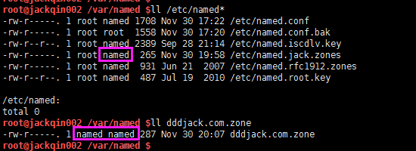

# systemctl restart named

重启

# systemctl enable named

开机启动

# systemctl status named

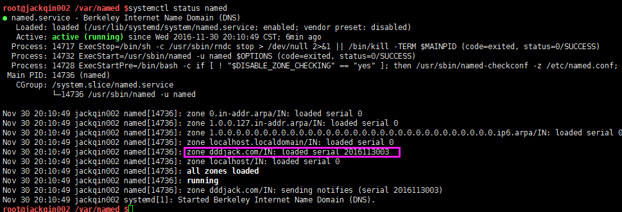

# firewall-cmd --add-port=53/udp –permanent

# firewall-cmd --add-port=53/tcp –permanent

# firewall-cmd --reload

# firewall-cmd --list-all

设置防火墙并生效并检查

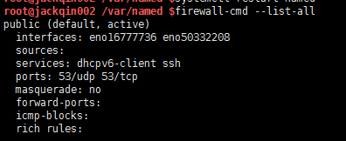

## 校验

# netstat -anotlp |grep :53

确认 DNS 服务启动

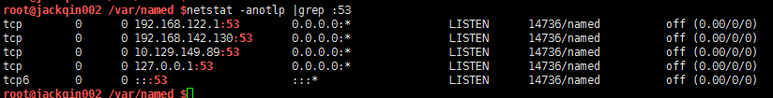

# dig www.baidu.com

# dig @192.168.142.130 www.baidu.com

# dig @192.168.142.130 www.baidu.com +trace

# dig @192.168.142.130 abc.dddjack.com

# dig @192.168.142.130 ab.dddjack.com

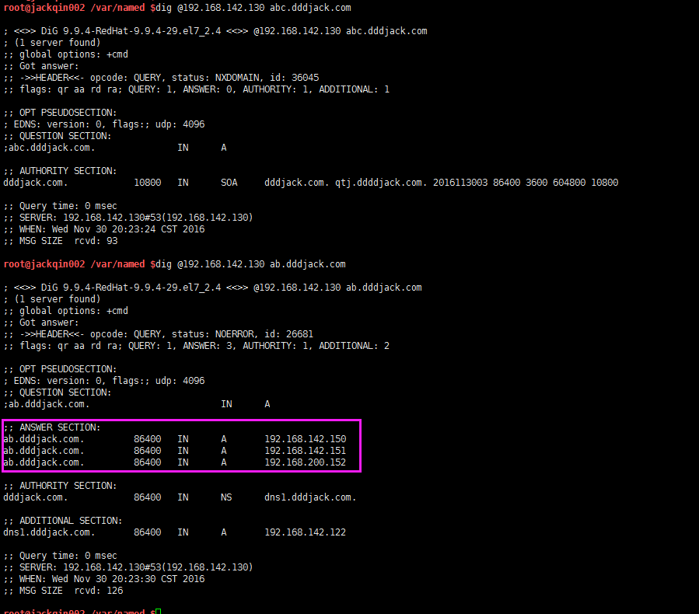

## 其他

修改 dddjack.com.zone, 并 systemctl restart named，重新 dig可以看到更新的DNS配置。

参考资料：

<http://www.centoscn.com/CentosServer/dns/2015/0403/5074.html> （CentOS 7系统上架设DNS服务）

<http://wenku.baidu.com/link?url=GGeXKTNP1Zgj2vPhxSMMY8WeiqVJmHQ0wRAbNbLXlsnoGSXB3X3WgdZBJDRxNDrORYo9wRJwjDo2bW3aV5p5e8jKXpOyUjhSc0mnjDLcQAa> （CentOS 7 安装DNS server 傻瓜操作指南）